**Q1**

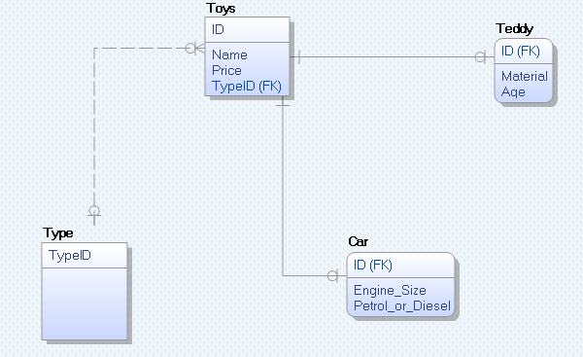

I’ve used table per concrete class as my design. There is non-identifying relationship between TOYS and TYPE table so each toy has Type Id. By this we can determine which attributes the toy will have. We will have to use joints to get attributes.

**Q2**

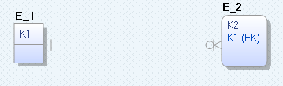**E1**

I’ve use identifying one to many relationship as there always has to be one value in table E_1 for many values in table E_2

CREATE TABLE E_1

(

K1 CHAR(18) NOT NULL

);

ALTER TABLE E_1

ADD CONSTRAINT XPKE_1 PRIMARY KEY (K1);

CREATE TABLE E_2

(

K2 CHAR(18) NOT NULL ,

K1 CHAR(18) NOT NULL

);

ALTER TABLE E_2

ADD CONSTRAINT XPKE_2 PRIMARY KEY (K2,K1);

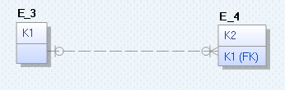**E2**

I’ve used non identifying one or zero to zero or many relationship as we don’t have to have a value in table E_3 and we can still have values in table E_4

CREATE TABLE E_3

(

K1 CHAR(18) NOT NULL

);

ALTER TABLE E_3

ADD CONSTRAINT XPKE_3 PRIMARY KEY (K1);

CREATE TABLE E_4

(

K2 CHAR(18) NOT NULL ,

K1 CHAR(18) NULL

);

ALTER TABLE E_4

ADD CONSTRAINT XPKE_4 PRIMARY KEY (K2);

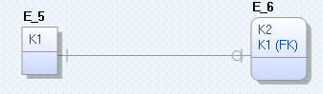**E4**

I’ve used identifying one to zero or one relationship as there has to be at least one value in table E_5 and there can be but doesn’t have to be a corresponding value in table E_6

CREATE TABLE E_5

(

K1 CHAR(18) NOT NULL

);

ALTER TABLE E_5

ADD CONSTRAINT XPKE_5 PRIMARY KEY (K1);

CREATE TABLE E_6

(

K2 CHAR(18) NOT NULL ,

K1 CHAR(18) NOT NULL

);

ALTER TABLE E_6

ADD CONSTRAINT XPKE_6 PRIMARY KEY (K2,K1);

ALTER TABLE E_2

ADD (CONSTRAINT R_2 FOREIGN KEY (K1) REFERENCES E_1 (K1));

ALTER TABLE E_4

ADD (CONSTRAINT R_3 FOREIGN KEY (K1) REFERENCES E_3 (K1) ON DELETE SET NULL);

ALTER TABLE E_6

ADD (CONSTRAINT R_13 FOREIGN KEY (K1) REFERENCES E_5 (K1));

**Q3**

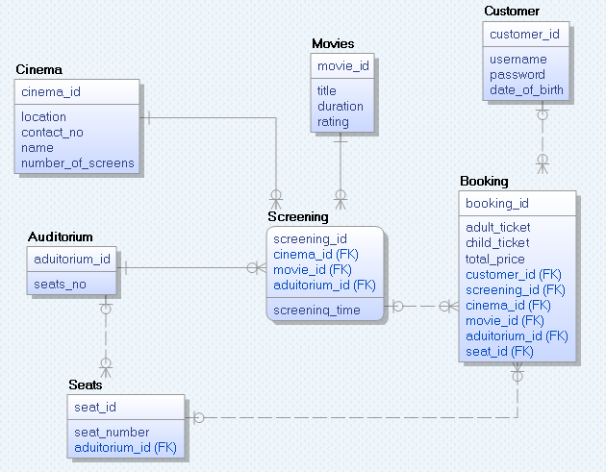

Booking table contain unique booking id, amount of adult tickets and child tickets, total price, customer id so we know who made the booking, screening id so we can find out when the movie will be played by joining the booking table with screening table, we also have the movie id, auditorium id and cinema id so we know in which cinema at which screen and which movie is played.